

International Maritime Training Centre

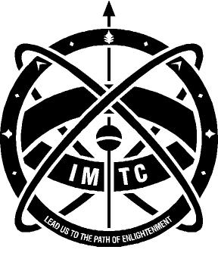

DECK CADET SELECTION 2019 - IMPORTANT INSTRUCTIONS

- It is mandatory for all candidates to appear and qualify in the CET (1 Year DNS programme) conducted by the Indian Maritime University (IMU) around May 2019. Please register and appear for the IMU CET.

- Selected candidates will be required to undergo a One Year Pre-sea training course (DNS) and basic modular courses (approximate cost Rs. 5,00,000/-).

- Appeared for 12th class (10+2) Board Exams after 1st January 2018 and passed the exam in 1st attempt. Candidates awaiting results can also apply.

- Prior starting their Shipboard Training the cadet will have to enroll in the Directorate General of Shipping (DGS) approved Structured Shipboard Training Programme (SSTP), the fees for which are to be borne by the cadet and is included in the above fees.

- During the apprenticeship there will be further training expenses.

- All selected candidates should be in possession of a valid Indian Passport prior completion of the pre-sea training course. The pre-sea training course is scheduled to commence around 16th July 2019.

- Any candidate found using unfair means, or having made false representations, will be disqualified immediately. Please be warned that there are no agents or any persons authorized to act on behalf of the Wilhelmsen Ship Management (India) Pvt. Ltd. with regard to the selection.

- The eyesight and medical standards in this career are quite strict.

- If selected for DNS programme, after the interview the candidate will have to undergo medical test and psychometric test, the cost of which (approximate Rs.8000/-) will have to be paid by the candidate.

- Online test for eligible candidates will be held at Mumbai. (dates of Online test will be informed to shortlisted candidates). Fees for online test will be approximately Rs. 700/-

- Based on performance in online test, if you are shortlisted for Interview:

A) Please bring your original mark-sheets of the 10th Class Board exams and if results are declared, the 12th class (10+2) Board Exams.

B) Candidates will be required to bring the IMU CET admit card and other relevant certificates and testimonials in original or attested copies at the time of interview.

C) All expenses incurred by way of travelling, boarding, lodging, etc during the selection procedure will have to be borne by the candidate.

- Selection criteria and selection process are at the sole discretion of Wilhelmsen Ship Management (India) Pvt. Ltd.

******************

